PATHALOGY

HEC No. 1428 _{ISSN No. 1681-5491} M E D I C A L
ORIGINAL PAPER
Vol. 15, No. 2

C H A N N E L
APRIL - JUNE 2009

1. AFTAB AHMED SOOMRO 2. JAWED AHMED BADVI 3. AMTUL HAFEEZ 4. AASIF DURANI
SERODIAGNOSIS OF AMOEBIC LIVER ABSCESS BY INDIRECT HAEMAGGLUTINATION TEST.
INTRODUCTION
Amoebiasis is an endemic problem in many tropical and subtropical areas. World Health organization (WHO) has estimated that about 50,000,000 cases of invasive amoebiasis occur annually and it is among the leading causes of death due to parasitic infections surpassed only by Malaria and Schistosomiasis¹. Amoebic liver
1.  2.  3.  4. | Assistant Professor  Department of Pathalogy DOW MEDICAL COLLEGE, KARACHI.  Lecturer  Dept. of Pathalogy  DOW MEDICAL COLLEGE, KARACHI.  Professor  LIAQUAT MEDICAL COLLEGE & DARUL SIHAT HOSPITAL, KARACHI.  Assistant Professor  Department of Pathalogy  BMSI, JPMC, KARACHI.  Correspondence to:  AFTAB AHMED SOOMRO  Assistant Professor of Microbiology  Department of Pathalogy DOW MEDICAL COLLEGE, KARACHI. | abscess is the most common extraintestinal manifestation of invasive amoebiasis²^{,3}. An immune dependant 170 KD surface protein of Entamoeba histolytica (EH) is considered to be essential for invasion of host tissue and it is responsible for resistance of the parasite towards hosts’ immune response. This protein is recognized by antibodies in the sera of patients with amoebiasis, and this circulating antigen has been used as a diagnostic marker for amoebic liver abscess.¹ Serodiagnosis of amoebic liver abscess by Indirect Haemagglutination (IHA) test is considered to be Sensitive and Specific by many researchers.^{4,5,6}  This study was designed to see the prevalence of amoebic liver abscess in Karachi with respect to socioeconomic status, living conditions, age and sex distribution, clinical signs and symptoms, radiological, and haematological laboratory findings and antiamoebic antibody titer level by haemagglutination (IHA) test.  SUBJECTS AND METHODS:  This study was conducted in the Department of Microbiology, Basic Medical Sciences Institute, JPMC, Karachi. A total of 100 cases of liver abscess were selected. The selection criteria was to include those cases who were clinically diagnosed for amoebic liver abscess and findings were confirmed on ultrasonography. Those cases that had hepatomegaly but were not diagnosed for amoebiasis clinically were excluded. For controls 100, age matched healthy individuals were selected. Hepatomegaly and amoebiasis was excluded in these cases on clinical assessment and ultrasonography. A sample of 5 ml blood collected from each case, serum was separated and samples were stored at 20º C, until tested for antibodies.  Indirect Haemagglutination test was run on the samples in batches, and for this purpose kit provided by Behring Diagnostic GMBH Marburg / Germany CELLOGNOST ® amoebiasis OTOMO G 1 7 C 20 (0927 ) H 1 Kit, (IHA) was used. According

ABSTRACT

OBJECTIVE : To assess the role of Indirect Haemagglutination Test for the diagnosis of amoebic liver abscess.
STUDY DESIGN : Comparative Study
PLACE AND DURATION : This study was carried out at Basic medical Sciences Institute, JPMC, Karachi from February 2000 to January 2001.
SUBJECTS AND METHODS : Blood samples were obtained from 100 cases of amoebic liver abscess and 100 age matched healthy individuals. Indirect haemagglutination test was performed on the serum to see the titres of antibodies to Entamoeba histolytica. RESULT : Significant antibody titres ranging from 1 : 256 - 1 : 4096 were observed in confirmed cases of amoebic liver abscess. While titres were non-significant in normal subjects. IHA was found to be 96% sensitive and 100% specific for the serodiagnosis of amoebic liver abscess.

KEY WORDS : Entamoeba histolytica, Hepatic amoebiasis, Indirect Haemagglutination
( I H A ) Test
to the test principle, specific antibodies cross link the sensitized erythrocytes in the reagent and form visible agglutinates. While in the absence of antibodies a button shaped deposit settles in the bottom of tube.⁷
Mean serum titers in infected cases range from 1:256 to 1:2048, while in the case of healed lesions low titers of 1:32 were observed. Titers of 1:128 are considered to be borderline and were repeated, while titers below 1:32 exclude invasive amoebiasis.⁵ All the 200 samples were subjected to IHA test and results were recorded. The serum antibody titers, in clinically established cases and controls were compared and the sensitivity and specificity of test was calculated.
TABLE 1.
INCOME |  |  | JOB |  | EDUCATION |  | TYPE OF AREA
A | B | C | Office | Manual | Yes | No | Slum | Semi urban | Urban
45 | 44 | 11 | 44 | 56 | 70 | 30 | 48 | 29 | 23
45% | 44% | 11% | 44% | 56% | 70% | 30% | 48% | 29% | 23%

Socio economic status of amoebic abscess patients
TABLE 2.
TABLE 2. TABLE 2.
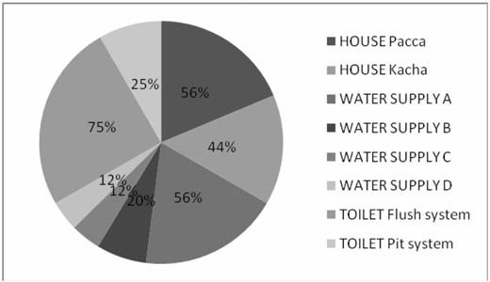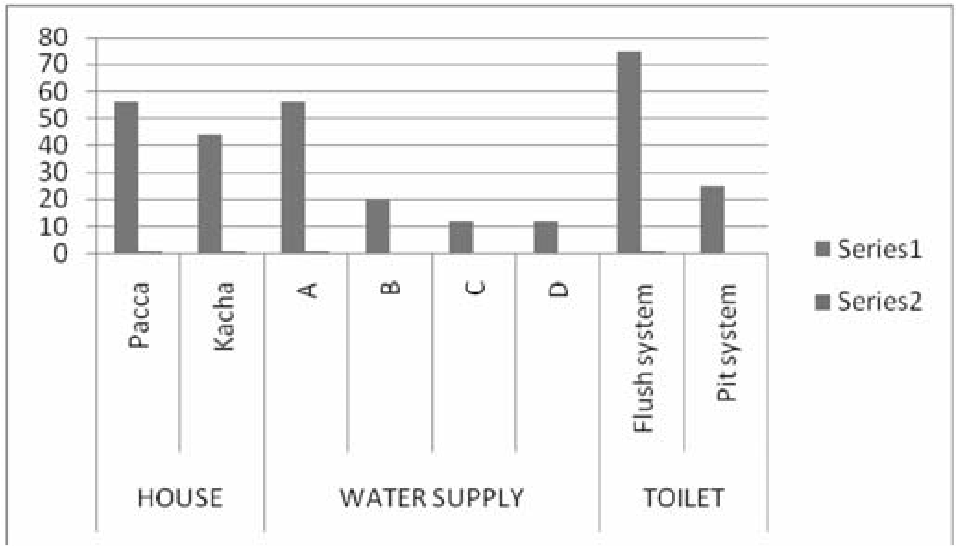
Living conditions of amoebic abscess patients
graphic representation
Living conditions of amoebic abscess patients
pie-graphic representation
Table 3:
RESULTS: AGE AND SEX DISTRIBUTION OF AMOEBIC LIVER ABSCESS PATIENTS.
Age Group | Male | Female
(Years) | (%) | (%)
A (11-20) n=17 | 16 | 1
B (21-45) n=40 | 37 | 3
C (46-60) n=31 | 29 | 2
D (61-85) n=12 | 10 | 2
Total: n=100 | 92 | 8
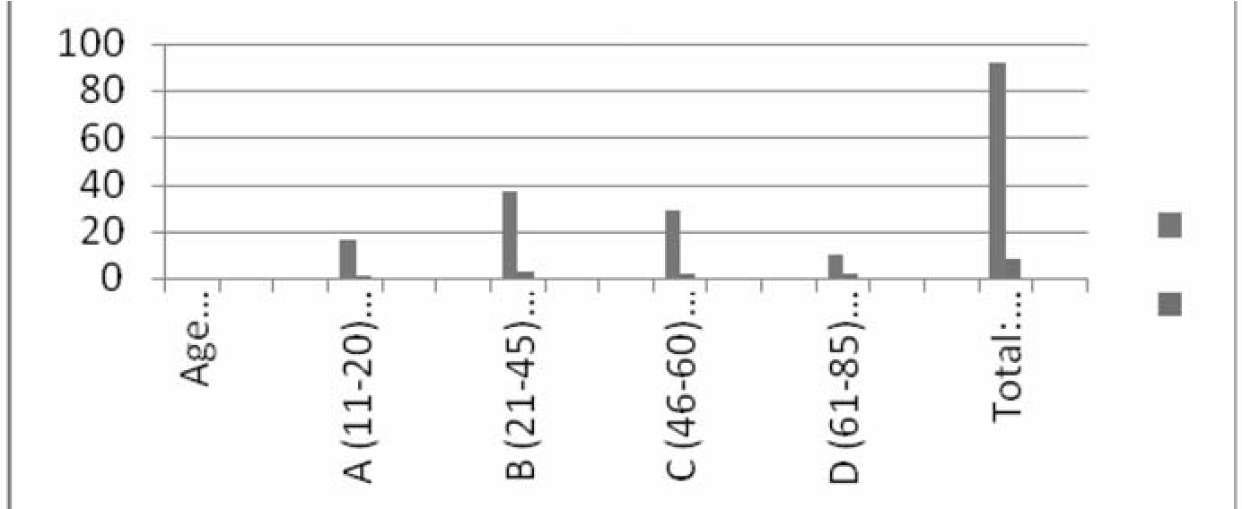
(Table 1) shows socioeconomic status of patients diagnosed amoebic for amoebic liver abscess. This included the total income, nature of job, education and type of residence where they lived. The group A included poor people and they were 45%. The group B included as middles class and they were 44%. The group C included the peoples above middle class and they were 11%. Forty four percent patients or their parents were workers and fifty six percent patients or their parents were manual workers. Seventy percent had education at primary level or above while the rest were illiterate. Majority of the patients (48) came from slum area, 29% came from semi urban area and only 23% from urban community.
(Table 2) shows living conditions of amoebic liver abscess patients as regards water supply and type of toilet. Fifty six percent had supply of water by water board ( A ), 20 % used the water supplied from community tap (B), 12% used the water supplied by
HOUSE |  | WATER SUPPLY |  |  |  | TOILET
Pacca | Kacha | A | B | C | D | Flush system | Pit system
56 | 44 | 56 | 20 | 12 | 12 | 75 | 25
56% | 44% | 56% | 20% | 12% | 12% | 75% | 25%
Living conditions of amoebic abscess patients
water tankers or carriers (C) and supply, and 74% had used water from more than one source. Regarding the type of toilet, 75% had flush system and 25% had pit latrine.
Table 3 shows age and sex distribution of amoebic liver abscess patients. They were divided in four groups. Group A included teenagers, age rangingfrom11 to 20 years. They were 17%, (male 16% and female 1%). Group B included young persons of 20 – 45 years and they were 40%, (male 37% and female 3%). Group C comprised of persons 46 to 60 years of age and they were 31%, (male 29% and female 2%). Group D comprised of old persons having more than 60 years of age. They were 12%, (male 10% and female 2%).
Clinical features were suggestive of amoebic liver abscess as shown in (Table 4). In these cases Fever, Pain in right Table No.4.
Signs and Symptoms on clinical examination in case of liver abscess.
SIGNS AND SYMPTOMS | NUMBER OF CASES (%)
Abdominal pain | 95
Fever | 95
Liver tenderness | 95
Hepatomegaly | 95
Anorexia | 56
Malaise | 48
Weight loss | 45
Chills and rigors | 30
Dyspnea | 25
Diarrhoea | 19
Cough | 13
Jaundice | 13
Spleenomegaly | 03

Table No.4. Table No.4.
Signs and Symptoms on clinical examination in case of Signs and Symptoms on clinical examination in case
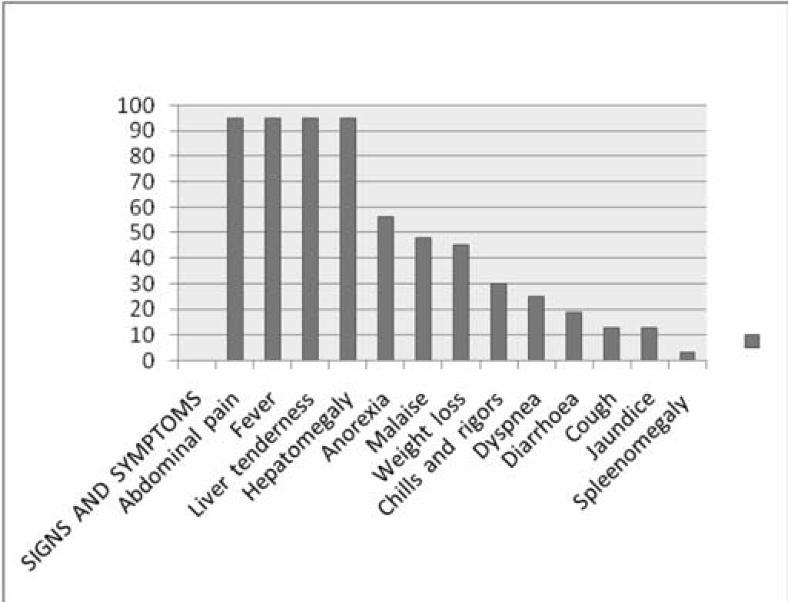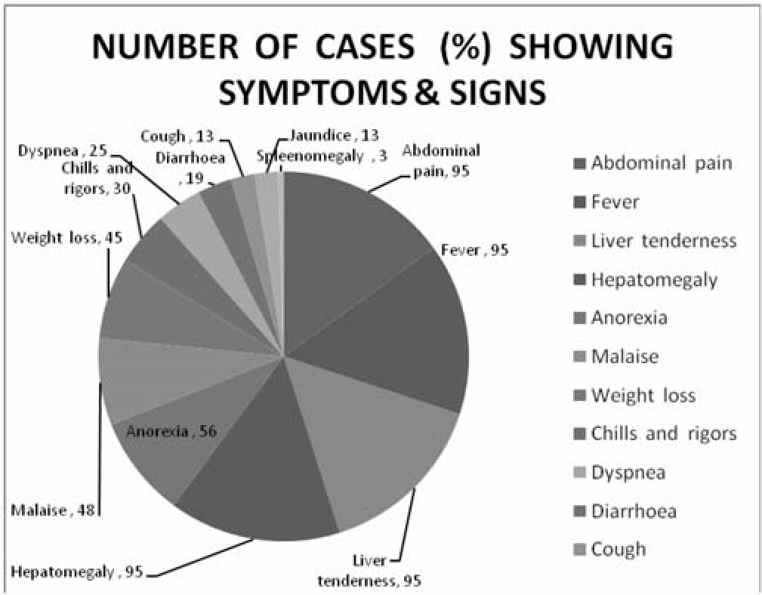
liver abscess
graphic representation
of liver abscess
piegraphic representation

hypochondrium, tenderness and hepatomegaly was the most common feature followed by anorexia and weight loss. (Table 5) revealed the X-Ray chest PA view findings, somewhat similar results from Pakistan⁹ and Taiwan¹⁵.
Table 6. show the ultrasonographic findings suggestive of liver abscess. The most prominent feature being the involvement of right lobe of liver in (80 %) cases. Table 7. shows the laboratory result of amoebic liver abscess patients. WBC count was slightly increased (11000- 25000/cmm) in 70% of patients. ESR was raised in 48% of cases. Haemoglobin < 10 gm% in 10% patients. Raised alkaline phosphatase > 90 IU/L was present in 44% cases, ALT > 40 IU/L in 30% of patients while total bilirubin was raised > 2mg% in 13%.
The antibody titers on IHA test in cases of amoebic liver abscess are shown in (Table 8). The titers indicate significant levels in 96 cases, while in 4 cases the titers were found to be below 1:256. These were considered as borderline and when repeated, showed lower titers. According to the observations and results of this study IHA test was found to be 100 % Specific and 96% Sensitive. The positive predictive accuracy was found to be 100 %.

DISCUSSION
This study was designed to see the prevalence of amoebic liver abscess in Karachi with respect to socioeconomic status, living conditions, age and sex distribution, clinical signs and symptoms, radiological, and haematological laboratory findings and antiamoebic titer level by haemagglutination (IHA) test. General information in each case revealed that the most of the patients were either from low income or middle class families. Majority of the patients were manual workers (Table 1) having some education at lower or higher secondary level. Patients come from all the five districts of Karachi because JPMC is one of the biggest hospital of this city . Some patients belonged to the suburbs of Karachi and of slum areas there were also a number of patients who came from interior of Sindh province. In the present study majority of patients were residents of slum areas (Tab. 1) which are

known to harbor many microbial agents Table No.5
X-RAY CHEST | PERCENT OF PATIENTS
Right hemidiaphragm elevation | 40%
Right pleural effusion | 05%
Normal | 55%
due to over crowding poor sanitation, Radiographic findings of amoebic liver abscess patiens unhygienic environment, polluted water and contaminated food supplies.
(Tab. 2) elaborates the water sources type of houses and toilets of the selected population, in majority of the cases due to over crowding poor sanitation, unhygienic environment, polluted water and
Table No.5. Table No.5.
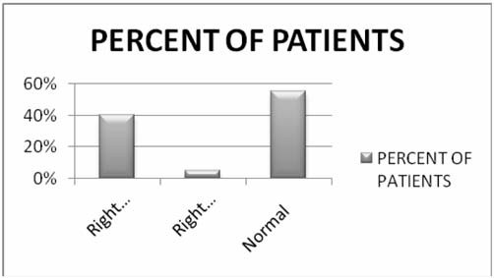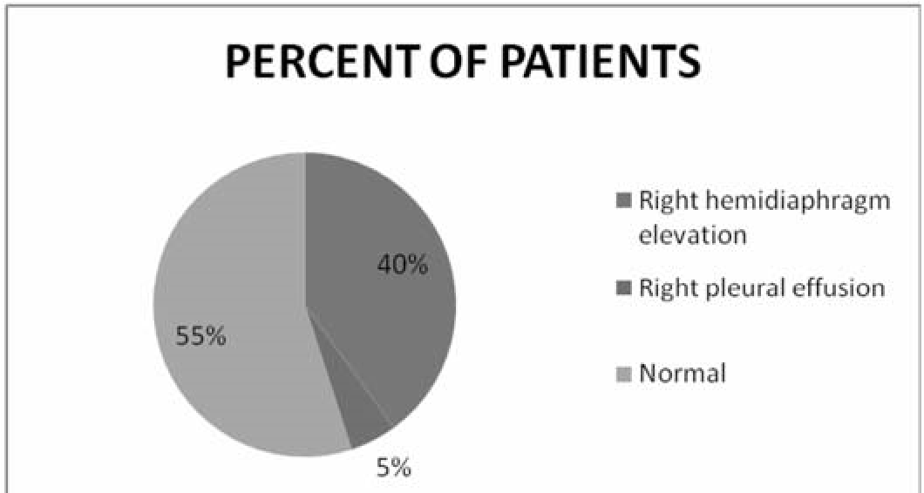
Radiographic findings of amoebic of liver abscess
graphic representation
Radiographic findings of amoebic of liver abscess
pie-
graphic representation

contaminated food supplies, all this comes in predisposing conditions. Western countries have also recently experienced a resurgence of amoebic liver abscess associated with immigrants, overcrowding and reduced living standards⁶.
In (Tab. 3) it is shown that males were found to be more affected than females. Similar pattern was also seen in Iraq¹³, in Pakistan⁹ in Japan¹⁶, India etc. it was noted that the amoebic liver abscess had occurred in all age groups in the present study, more or less equally, but the prevalence rate was higher in the age group between 20-45 years. In (Tab. 4) patient´s history and physical examination revealed that fever, right upper abdominal pain, hepatic tenderness and hepatomegaly were present in 95%. The other symptoms were anorexia chills, weight loss, malaise, dyspnea, diarrhea, cough and slight speeleenomegally. Similar results were obtained with little difference from Pakistan^{9&6}, from iraq¹³, Taiwan¹⁵ and India.
(Tab. 5) revealed the X-Ray chest PA view findings, somewhat similar results from Pakistan^{9,} and Taiwan¹⁵.
(Tab. 6) show the ultrasonographic findings suggestive of liver abscess. The most prominent feature being the involvement of right lobe of liver( 80 % ) cases. More or less these findings mimic with others studies from Pakistan. ^{9,14,} and Taiwan¹⁵. The laboratory investigations in amoebic liver abscess patients are shown in (Tab. 7) with Table No.6.
Size and Location of amoebic of liver abscess on ultrasonography
Size | Mean size (cm) | Percent of Patients
 | > 5 cm | 30 %
 | = 5 cm | 70 %
Location | Right Lobe | 81 %
 | Single | 88%
 | Multiple | 12 %
 | Left Lobe | 14 %
 | Both Lobes | 05 %
TABLE No. 7
Abnormal laboratory results of 100 patients with amoebic liver abscess
 | LABORATORY RESULTS |  | PERCENT OF PATIENTS
 | White blood cell counts (>11,000 – 25,000/mm³) |  | 70
 | ESR > 10 mm |  | 48
 | Haemoglobin < 10g % |  | 10
 | Alkaline posphatase > 90 U/L |  | 44
 | ALT > 40 U/L |  | 30
 | Total bilirubin > 2mg % |  | 13
some variations from Pakistan^{9,14,15}.  Serum titers of antiamoebic antibodies in different age groups are shown in (Tab. 8). The titers indicate significant levels in 96 cases, while in 4 cases the titers were found |  | to be below 1:256. These were considered as borderline and when repeated, showed lower titers. According to the observations and results of this study IHA test was found to be 100 % Specific and 96 %
TABLE No. 7- TABLE No. 7-
Abnormal laboratory results of 100 patients with amoebic Abnormal laboratory results of 100 patients with amoebic liver abscess pie-graphic resentation liver abscess pie-graphic resentation
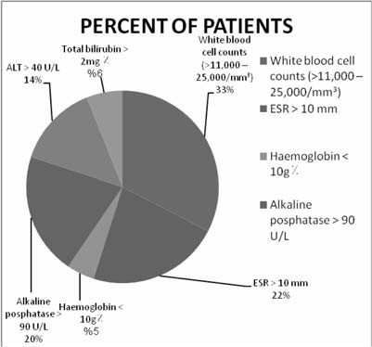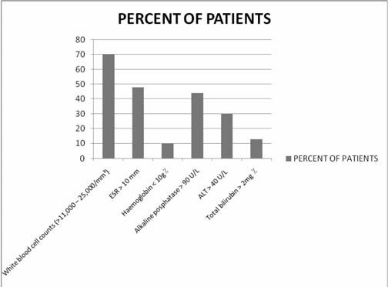
Sensitive.
The positive predictive accuracy was found to be 100 %.

CONCLUSION
In the light of results of this study it can be suggested that IHA still remains a reliable, economic and easily performed diagnostic tool which can be recommended for serodiagnosis of amoebic liver abscess. It is concluded that IHA test is a sensitive and specific test for diagnosis of amoebic liver abscess.
REFRENCES:
- Lotter, H. Mannweiler, E.,Schreiber, M. and Tannich,E. (1992) Sensitive and specific serodignosis of invasive amoebiasis by using recombinant surface protein antigen of pathogenic Entamoeba histolytica. J.Clin.Microbiol. 30(12):31+63-67
- Beaver, P.C., Jung, R.C., and Cupp, E.W. Amoeba inhabiting the alimentary canal In: Clinical Parasitology, 9 Ed . Lee and Febiger Publication,1984;101-116
- Chaterjee, K. D. Subphylum sarcomastigophora In: Parasitology Protozology and Helminthology, 13 Ed. 1987; pp 14-69
- Khan .M.H., Qamar R. and Shaikh, Z (1989) Serodiagnosis of amoebic liver abscess by IHA method JPMA pp262264
- Hartmann, D.P., Ghadirian, E. and Meerovich, E. (1980) Enzyme Linked Immunosorbent Assay (ELISA) and Indirect Heamagglutination (IHA) test in the serodiagnosis of of experimental
TABLE No. 8 -
IHA Serum titers in patients of amoebic liver abscess
Age Group/ Level of titer | 1:128 | 1:256 | 1:512 | 1:1024 | 1:2048 | 1:4026
A (11-20) n=17 | 1 | 0 | 8 | 5 | 2 | 1
B (21-45) n=40 | 2 | 2 | 15 | 12 | 7 | 2
C (46-60) n=31 | 1 | 1 | 13 | 10 | 4 | 2
D (61-85) n=12 | 0 | 0 | 6 | 4 | 2 | 0
Total | 4 | 3 | 42 | 31 | 15 | 5
hepatic amoebiasis. J. Parasitology 78:136-141.
66(2):344-345 12) Hira P R, Iqbal J, Al Ali F, Phillip
- Moazam, F. and Nazir, Z. (1988) K, Groversand D almeida E and Al Amoebic Liver Abscess: Spare the Knife Eneizi A A. invasive amoebiasis. but Save the Child. J. Pediatr. Surg. Challenges in diagnosis in a
33(1):119-122 nonendemic country, Kuwait. American
- Cheesberough M. Principles of Journal of Tropical Medicine and Immunity. Serological diagnosis of Hygiene. 2001. 45:341-345
Microbial diseases by agglutination 13) Mahdi, N.K., Al Obaidi, F. and Benyan, tests. Medical Laboratory manual for A.Z. (1989) Hepatic abscess among Tropical Countries. Butterworth- Iraqi patients. JPMA 259 – 261.
Heinmann 1984:Vol.II: 84-86 14) Mehnaz, A. and Azhar, A.S.M. (1999)
- Ravdin, J.I (1995) Amoebiasis. Clin. Liver abscess in children not an Infect. Dis. 20:1453-66. uncommon Problem
- Sheikh Z, Khan M S and Qamar R. 15) Chuah, S., Chang-Chien, C., Sheen, et clinical profile of 100 cases of liver al. (1992) The prognostic factors of abscess. JPMA 1989:256-259 severe amoebic liver abscess; a
- Nanda, R., Baveja, U. and Anand, B.S., retrospective study of 125 cases. Am. J. Entamoeba Histolytica cyst passers, Med. Hyg. 46(4): 398-402 clinical features and outcomes in 16) Ohnishi, K and Murata, M. (1997).
untreated subjects. Lancet, 1984 2:301. Present characteristic of symptomatic
- Marcel. Patterson, Healy G.R and amoebiasis due Entamoeba histolytica Shabot J.M. serologic testing for in the east south-east area of Tokyo.
amoebiasis. Gastroenterology 1980 Epidemol. Infec. 119:363-67

